The Economics of Money, Banking, and Financial Markets, (Mishkin)
Chapter 6 The Risk and Term Structure of Interest Rates

1) The risk structure of interest rates is
A) the structure of how interest rates move over time.
B) the relationship among interest rates of different bonds with the same maturity.
C) the relationship among the term to maturity of different bonds.
D) the relationship among interest rates on bonds with different maturities.
Answer: B

2) A bond with default risk will always have a ________ risk premium and an increase in its default risk will ________ the risk premium.
A) positive; raise
B) positive; lower
C) negative; raise
D) negative; lower
Answer: A

3) Other things being equal, an increase in the default risk of corporate bonds shifts the demand curve for corporate bonds to the ________ and the demand curve for Treasury bonds to the ________.
A) right; right
B) right; left
C) left; right
D) left; left
Answer: C

4) Bonds with relatively high risk of default are called
A) Brady bonds.
B) junk bonds.
C) zero coupon bonds.
D) investment grade bonds.
Answer: B

5) Which of the following long-term bonds has the highest interest rate?
A) Corporate Baa bonds
B) U.S. Treasury bonds
C) Corporate Aaa bonds
D) Municipal bonds
Answer: A

6) Risk premiums on corporate bonds tend to ________ during business cycle expansions and ________ during recessions, everything else held constant.
A) increase; increase
B) increase; decrease
C) decrease; increase
D) decrease; decrease
Answer: C

7) The collapse of the subprime mortgage market increased the spread between Baa and default-free U.S. Treasury bonds. This is due to
A) a reduction in risk.
B) a reduction in maturity.
C) a flight to quality.
D) a flight to liquidity. Answer: C

8) When the Treasury bond market becomes more liquid, other things equal, the demand curve for corporate bonds shifts to the ________ and the demand curve for Treasury bonds shifts to the ________.
A) right; right
B) right; left
C) left; right
D) left; left
Answer: C

9) Municipal bonds have default risk, yet their interest rates are lower than the rates on default-free Treasury bonds. This suggests that
A) the benefit from the tax-exempt status of municipal bonds is less than their default risk.
B) the benefit from the tax-exempt status of municipal bonds equals their default risk.
C) the benefit from the tax-exempt status of municipal bonds exceeds their default risk.
D) Treasury bonds are not default-free.
Answer: C

10) The Bush Administration tax cut reduced the top income tax bracket from 39% to 35% over a ten-year period. Supply and demand analysis predicts the impact of this change was a ________ interest rate on municipal bonds and a ________ interest rate on Treasury bonds.
A) higher; lower
B) lower; lower
C) higher; higher
D) lower; higher
Answer: A

11) Three factors explain the risk structure of interest rates:
A) liquidity, default risk, and the income tax treatment of a security.
B) maturity, default risk, and the income tax treatment of a security.
C) maturity, liquidity, and the income tax treatment of a security.
D) maturity, default risk, and the liquidity of a security.
Answer: A

12) An inverted yield curve
A) slopes up.
B) is flat.
C) slopes down.
D) has a U shape.
Answer: C

13) If the expected path of one-year interest rates over the next five years is 4 percent, 5 percent, 7 percent, 8 percent, and 6 percent, then the expectations theory predicts that today's interest rate on the five-year bond is
A) 4 percent.
B) 5 percent.
C) 6 percent.
D) 7 percent.
Answer: C

14) According to the segmented markets theory of the term structure
A) the interest rate on long-term bonds will equal an average of short-term interest rates that people expect to occur over the life of the long-term bonds.
B) buyers of bonds do not prefer bonds of one maturity over another.
C) interest rates on bonds of different maturities do not move together over time.
D) buyers require an additional incentive to hold long-term bonds.
Answer: C

15) According to the liquidity premium theory of the term structure
A) bonds of different maturities are not substitutes.
B) if yield curves are downward sloping, then short-term interest rates are expected to fall by so much that, even when the positive term premium is added, long-term rates fall below short-term rates.
C) yield curves should never slope downward.
D) interest rates on bonds of different maturities do not move together over time.
Answer: B

16) According to the liquidity premium theory of the term structure, a downward sloping yield curve indicates that short-term interest rates are expected to
A) rise in the future.
B) remain unchanged in the future.
C) decline moderately in the future.
D) decline sharply in the future.
Answer: D

17) In actual practice, short-term interest rates and long-term interest rates usually move together; this is the major shortcoming of the
A) segmented markets theory.
B) expectations theory.
C) liquidity premium theory.
D) separable markets theory.
Answer: A

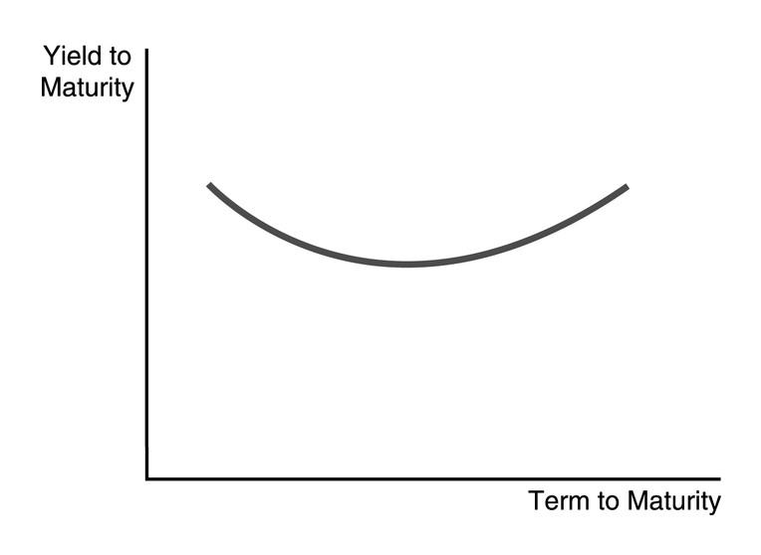
18) The U-shaped yield curve in the figure above indicates that short-term interest rates are expected to
A) rise in the near-term and fall later on.
B) fall sharply in the near-term and rise later on.
C) fall moderately in the near-term and rise later on.
D) remain unchanged in the near-term and rise later on.
Answer: B

